Below is the basic example of how to write a basic cucumber program

First create feature file with extension as .feature

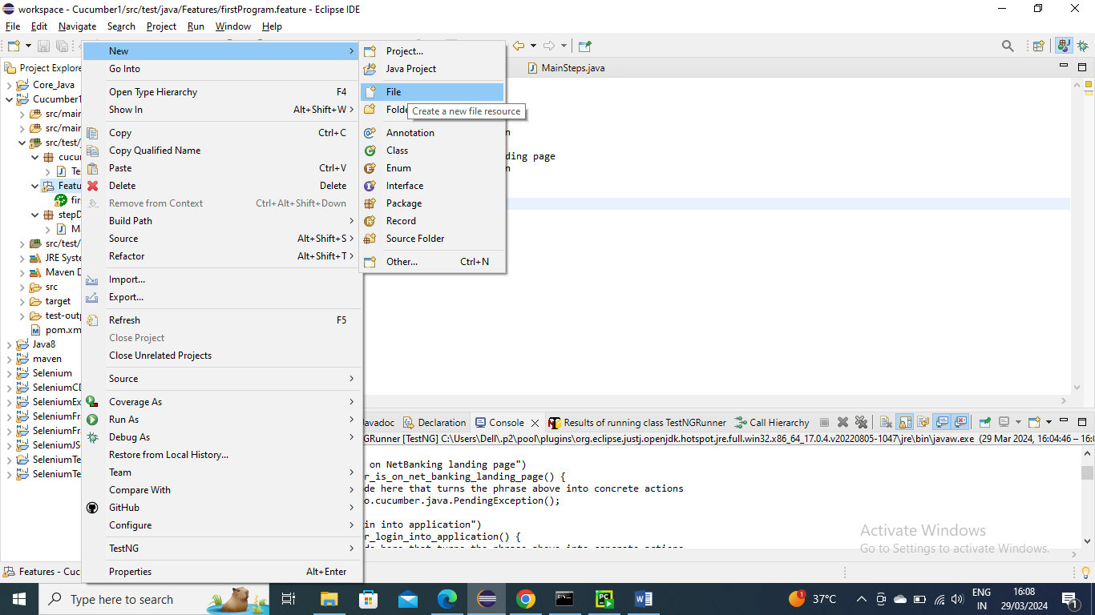

In below I have given basic login scenario

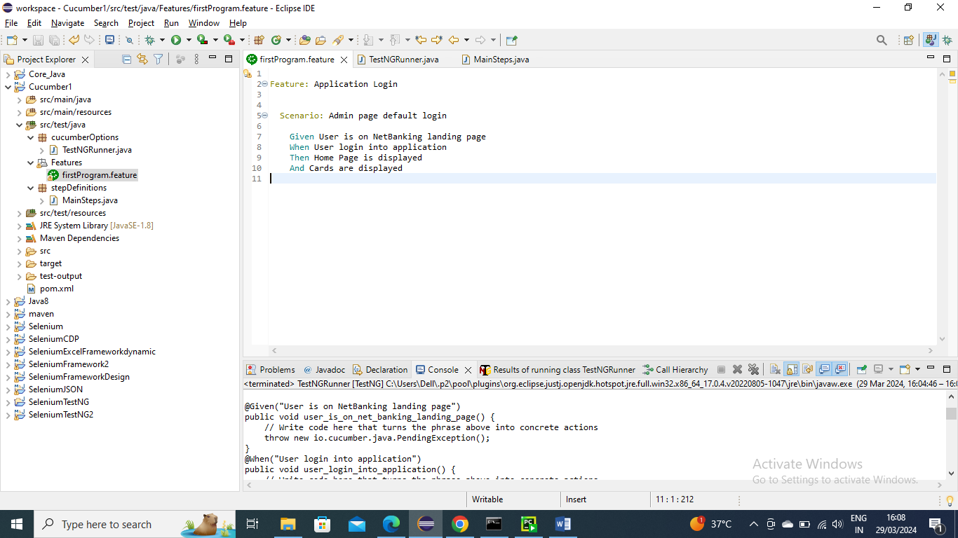

Now create a java program (you can have any name) which should extend with AbstractTestNGCucumberTests and it should be annotated with @CucumberOptions

In that we have to give path for “fetaures” and glue should be the package which has information of feature file and monochrome = true means it will give output with plain colours

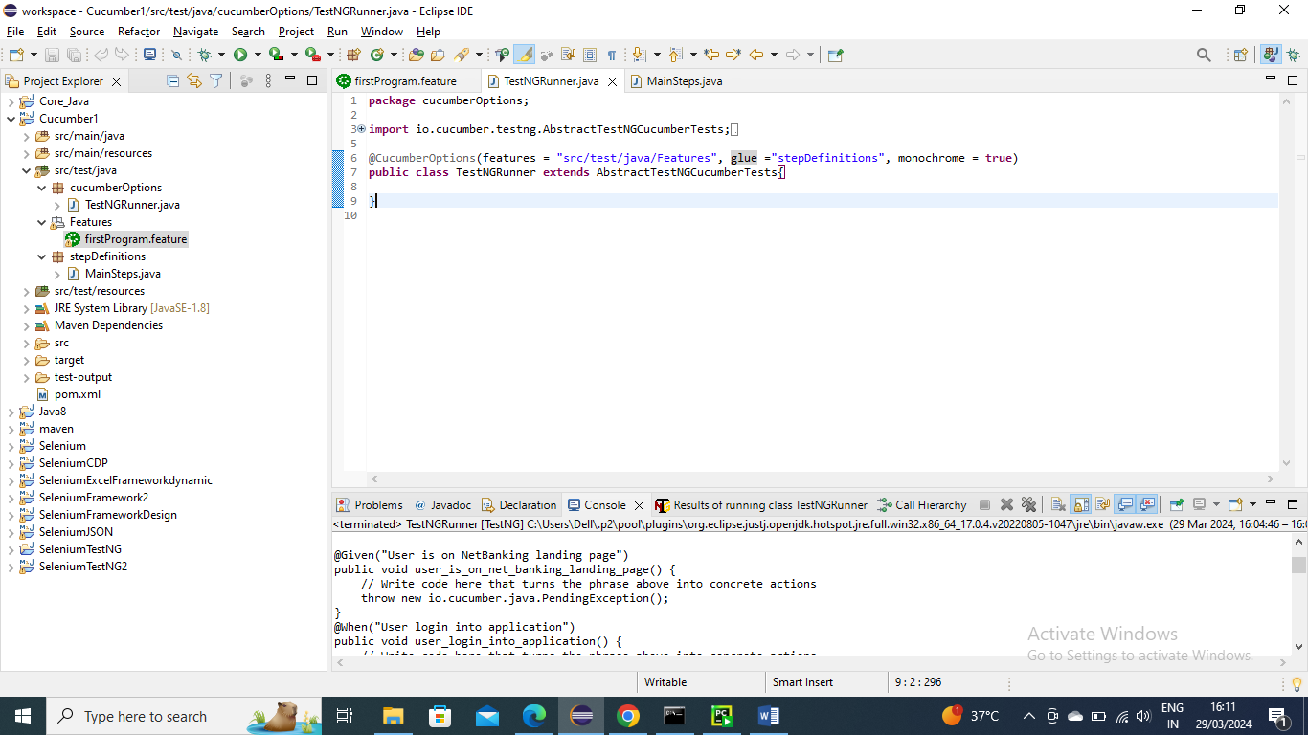

Now say I haven’t created any program In stepDefinitions where the feature scenarios are not created(I mean the methods) and we run the main program….the cucumber will understand that no implements are there and it will give us the info what should be created

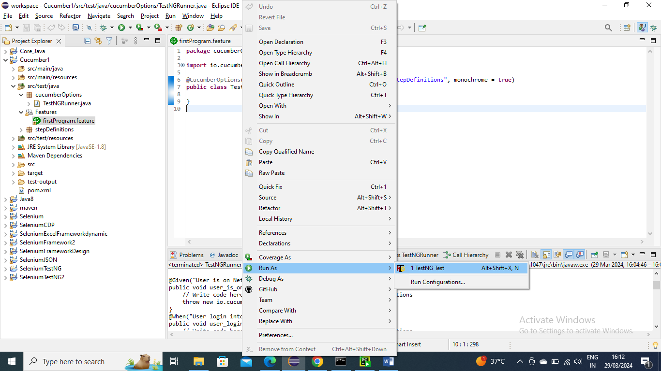

Now after running the test you can see in Console it is saying that these methods needs to be created….Please note it’s not mandatory to give method name also same I have modified wantedly to should method name can be different only annotation name should be same as feature file

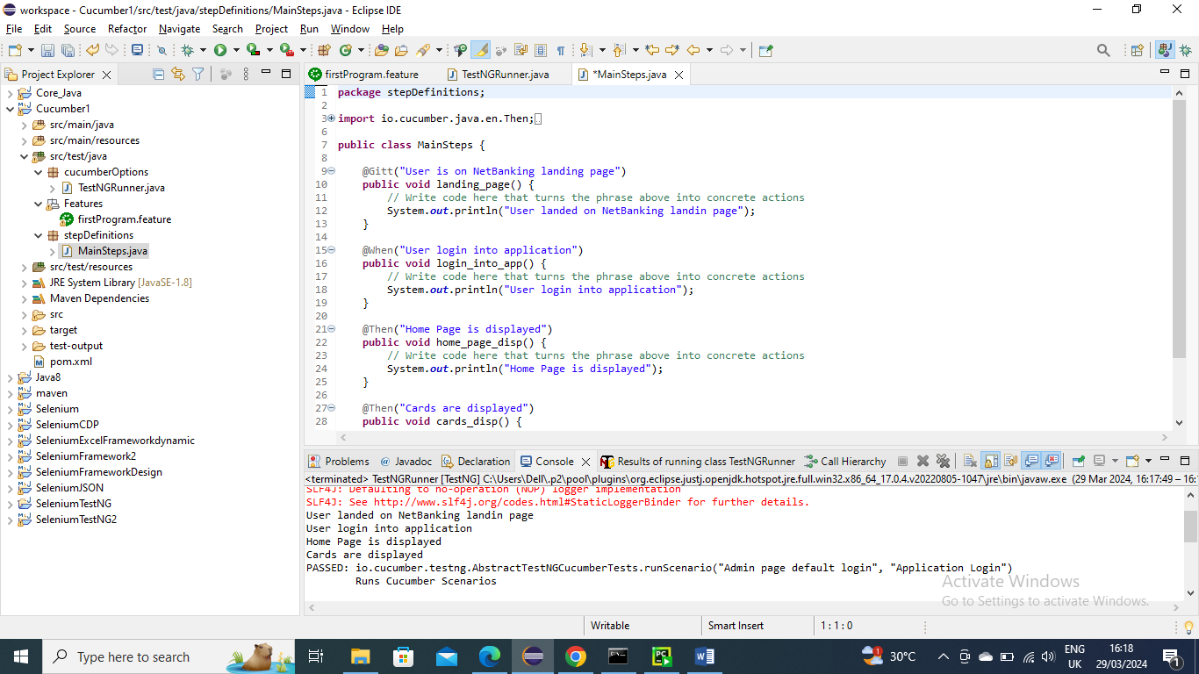

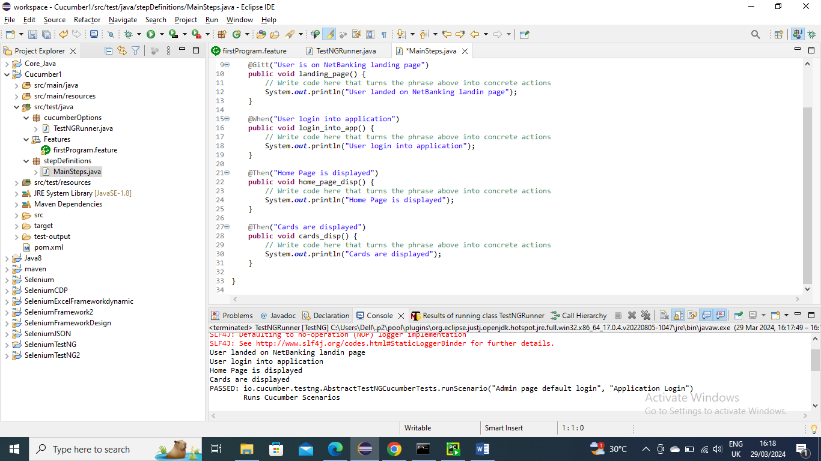

Below is the ouput after I ran main program i.e TestNGRunner class

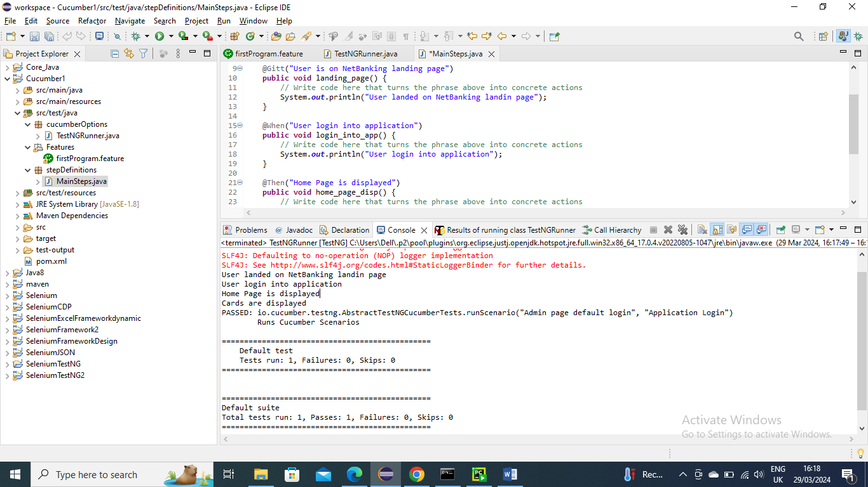

--------------------------------

Re-Usability in Cucumber

Let’s say you want to use same conditions (given, when and then) in two scenarios of “Admin page” and “User page”

Since both the scenarios having same conditions you don’t need to declare those methods multiple times only one method will be used for both scenarios

Below is an example

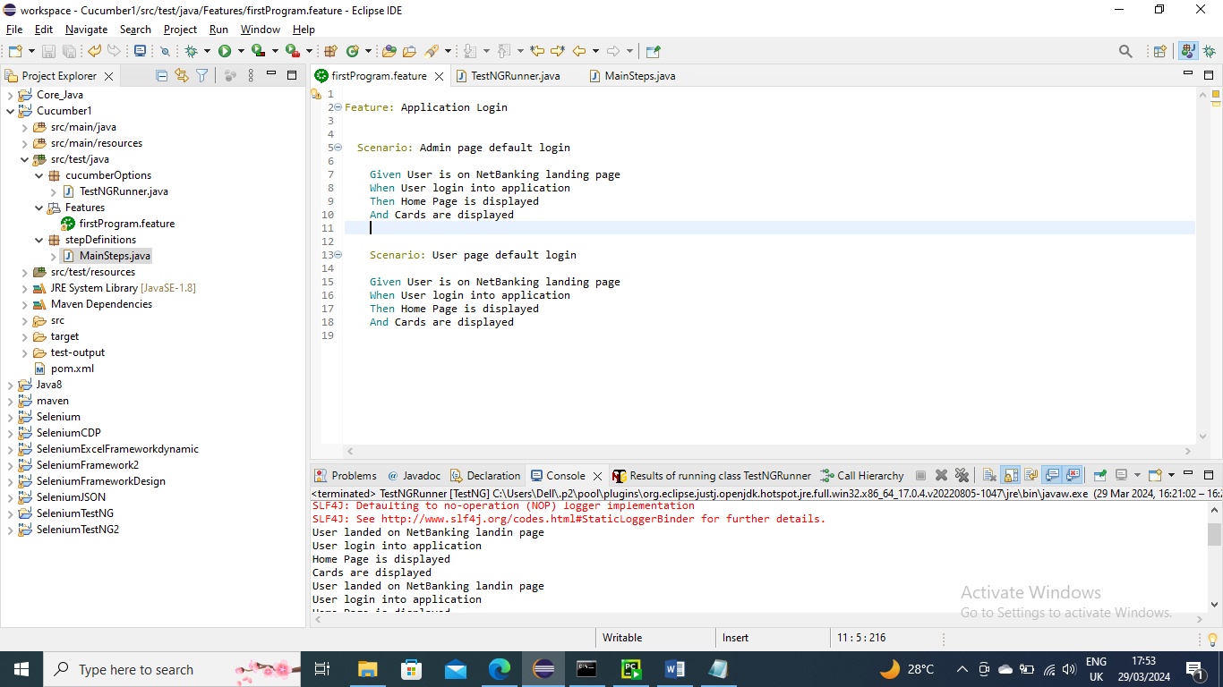

Only one methods from both scenarios

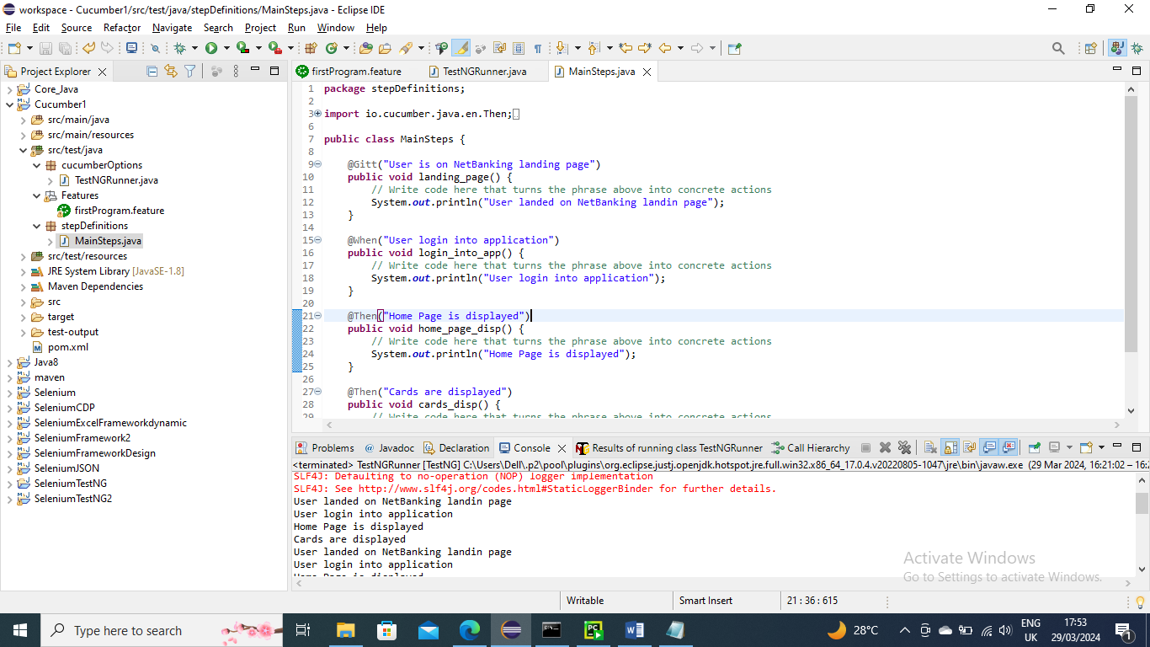

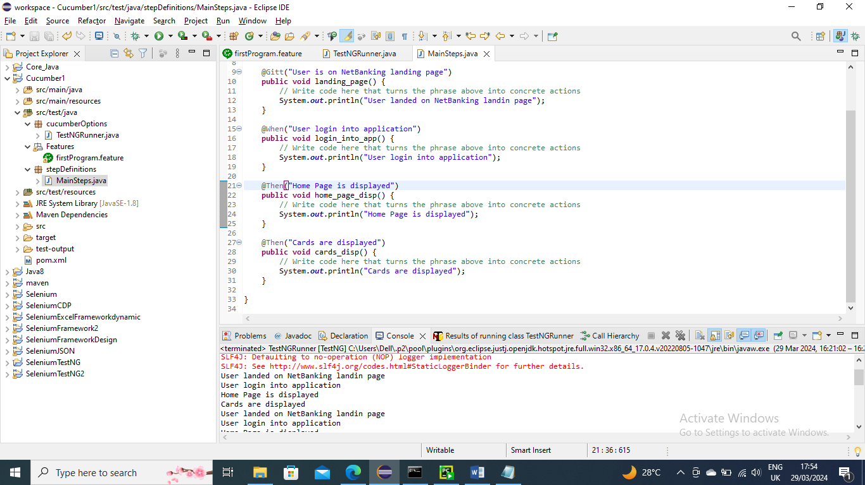

Now run from main class

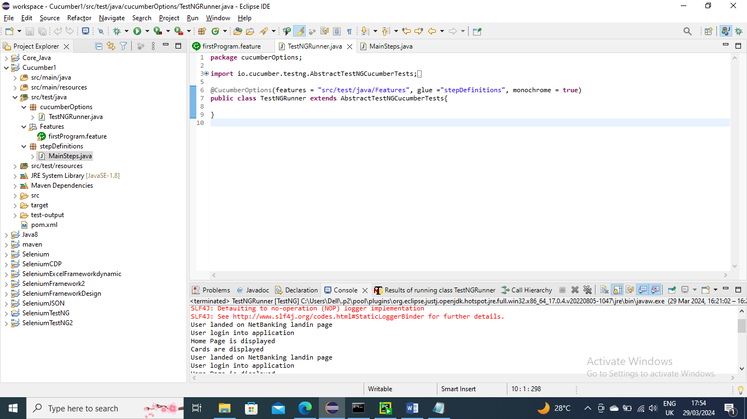

Below is the output you can see all methods ran twice since there are two scenarios

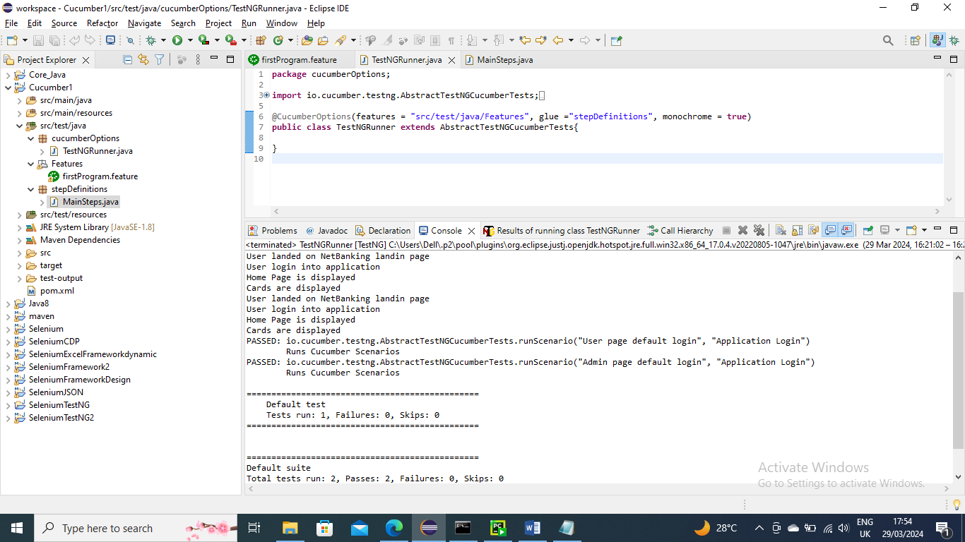

------------------------------------------

Let’s say once condition is different in another scenarios.

Below is the one that is different

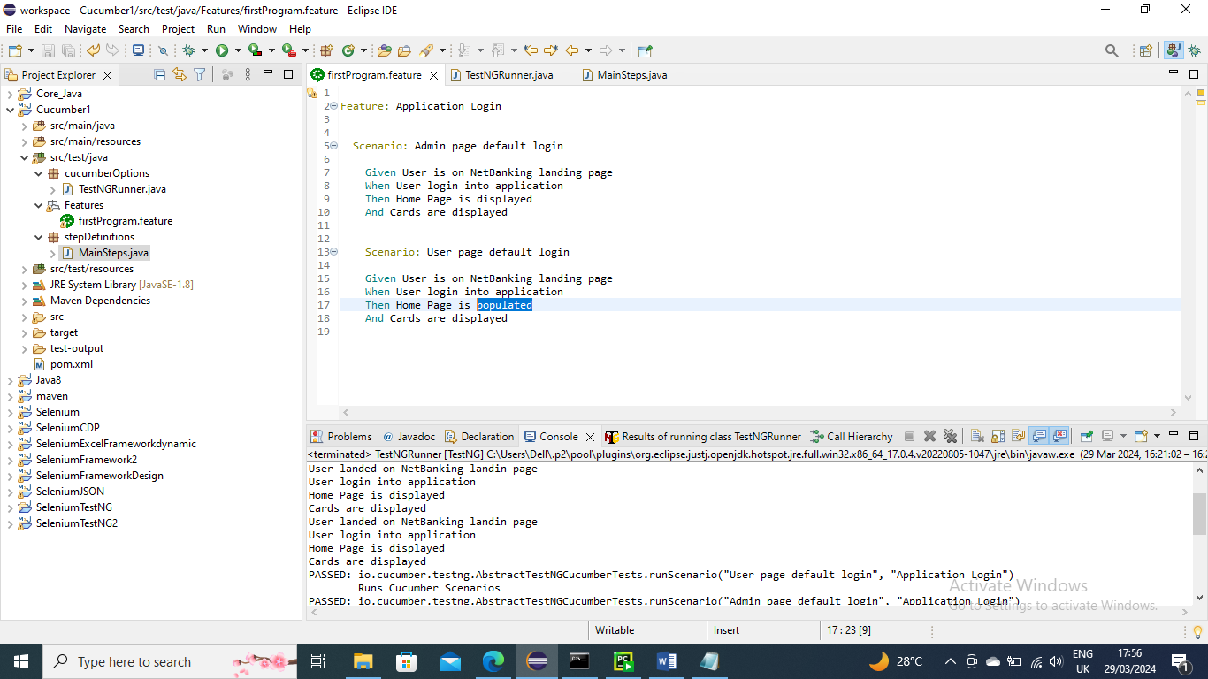

Then you need to create/declare a method in that class for that one

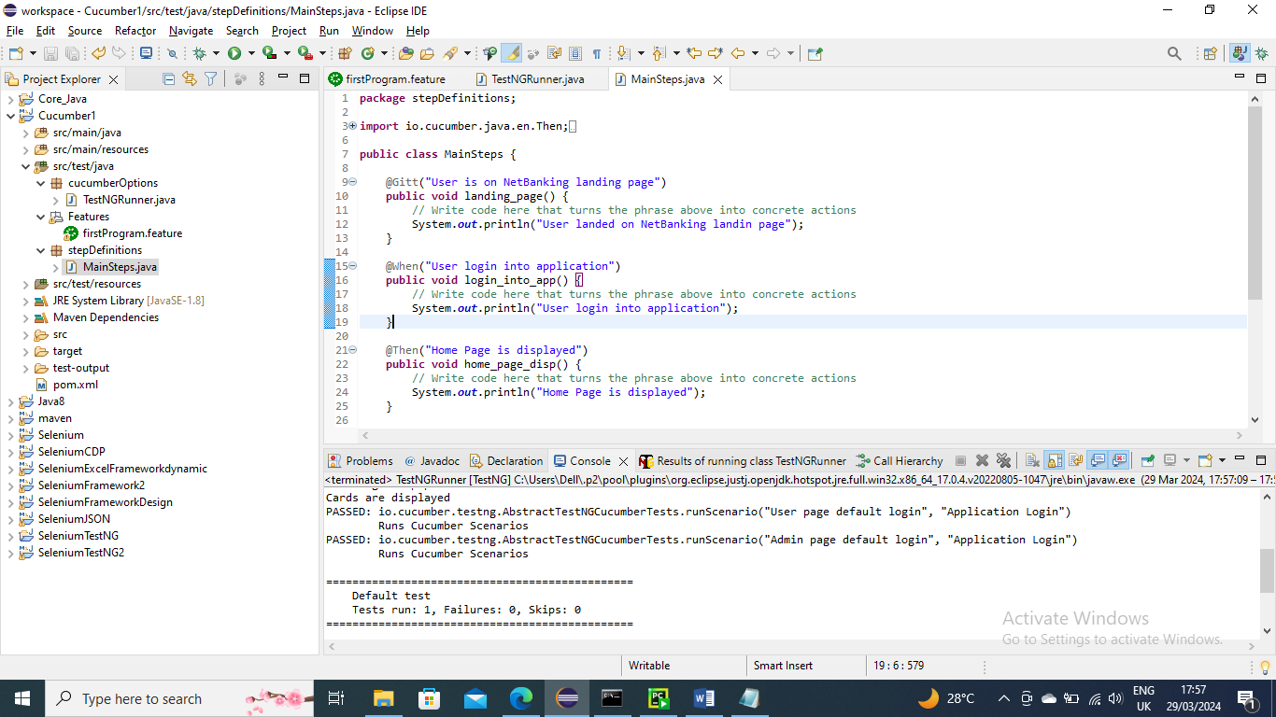

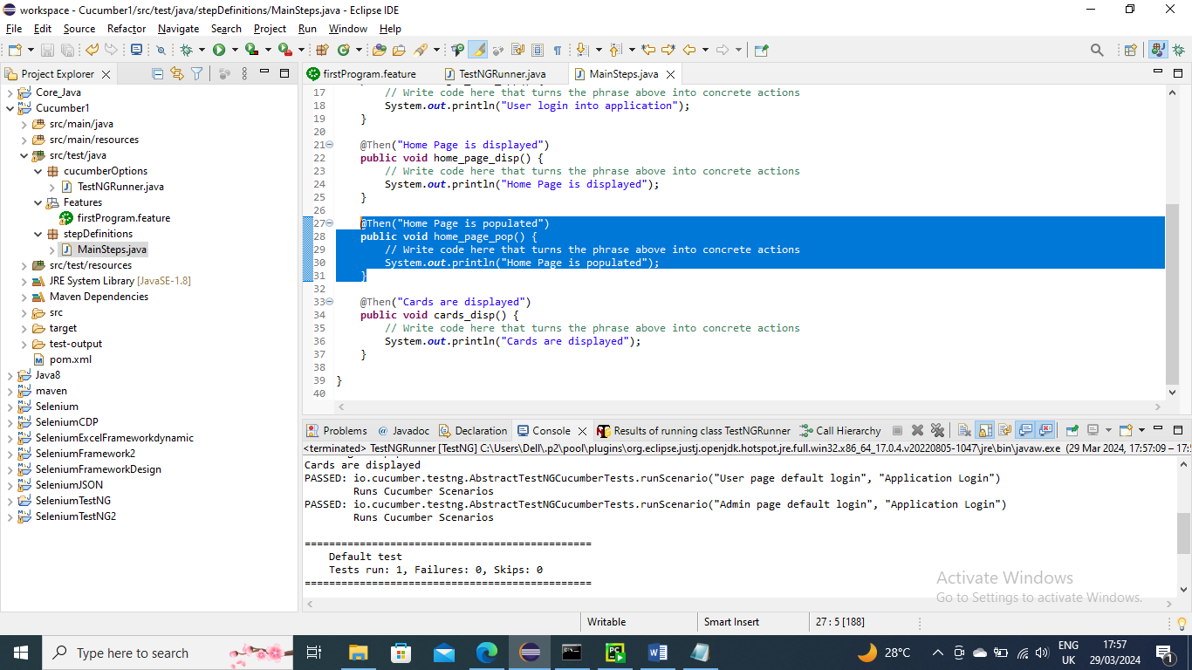

Now run from main class

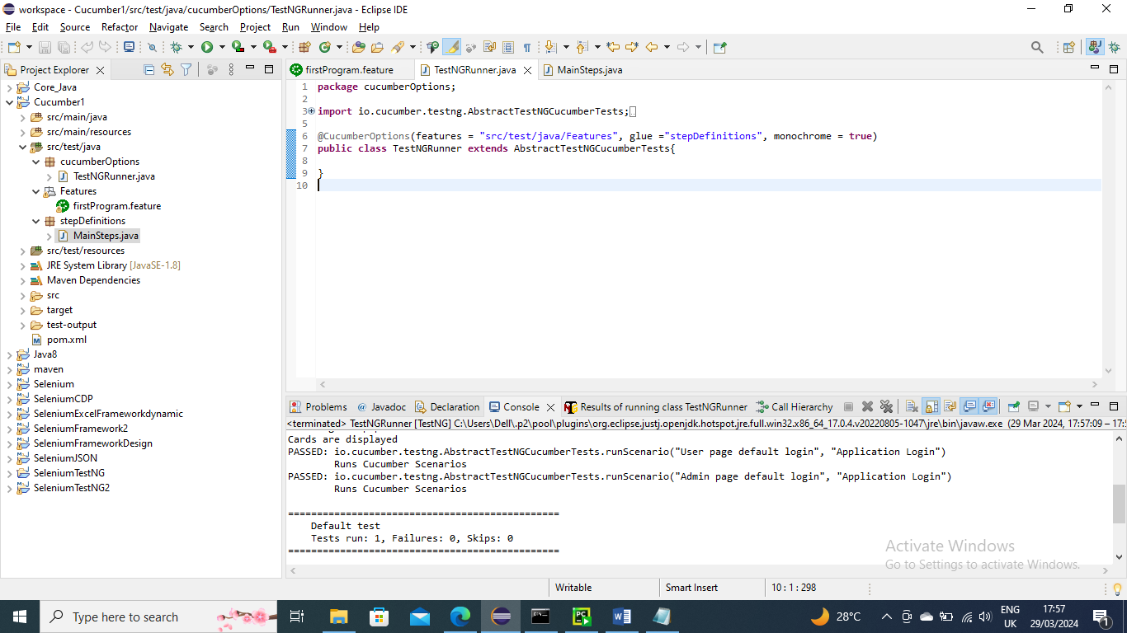

Below is the output. As you can see new created method ran

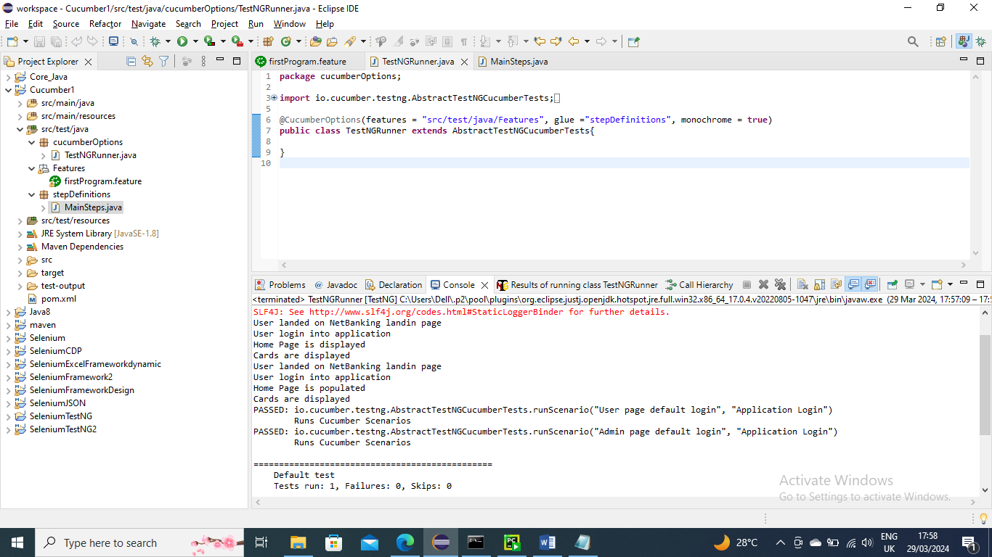

--------------------------------------------

Passing parameter to condition in a scenario

Let’s say we need to pass parameters to a when condition say username and password for login for Admin and user page

You can make changes in feature file as below

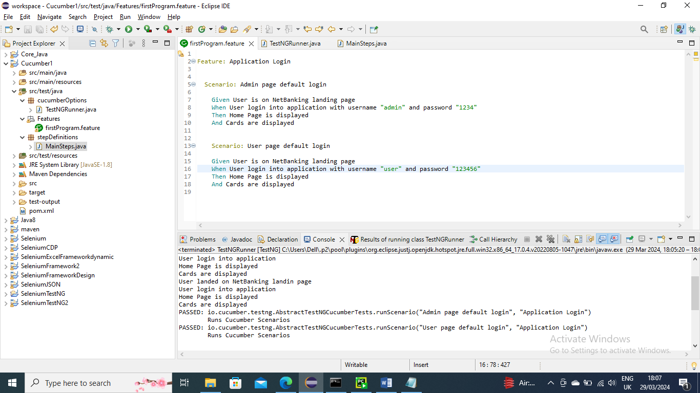

Make changes in stepDefinition file to accommodate the parameters

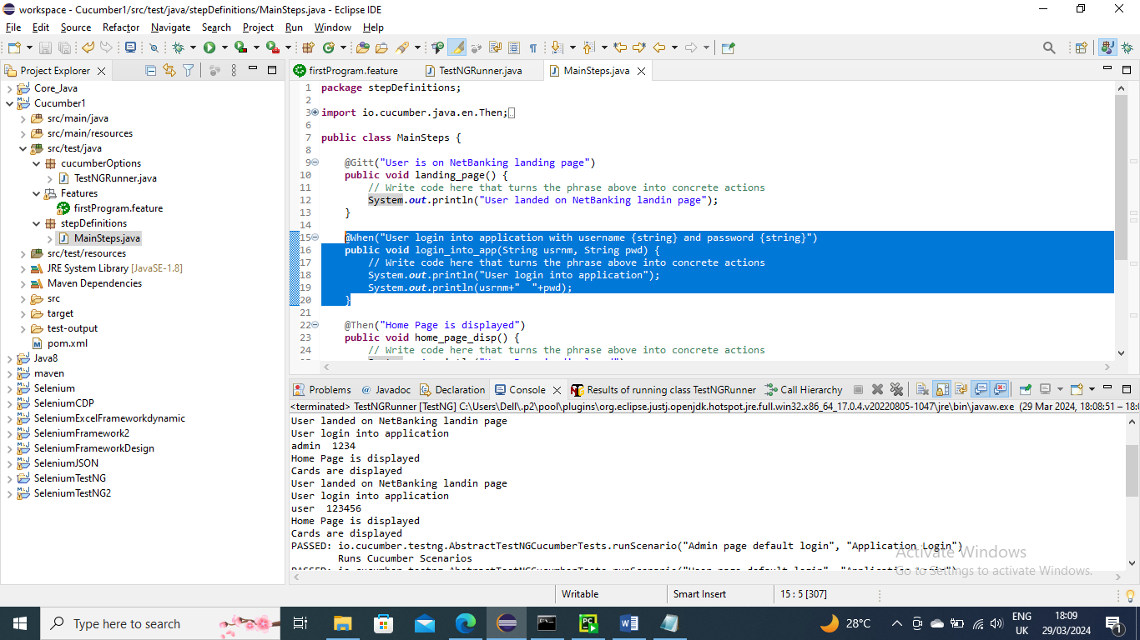

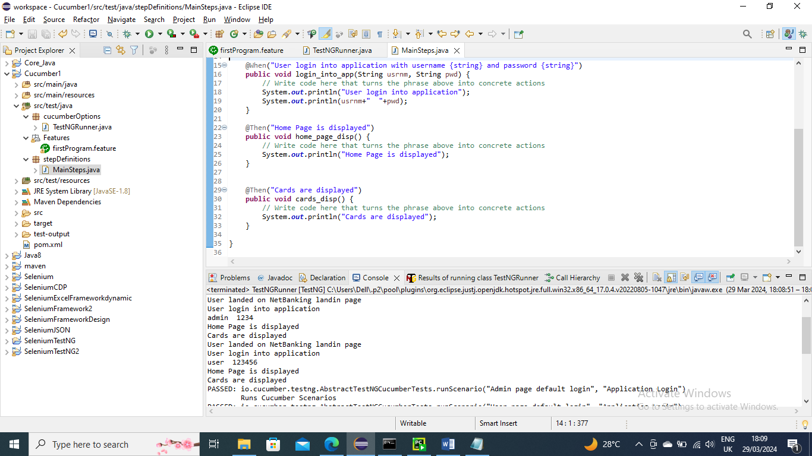

Now run the main class

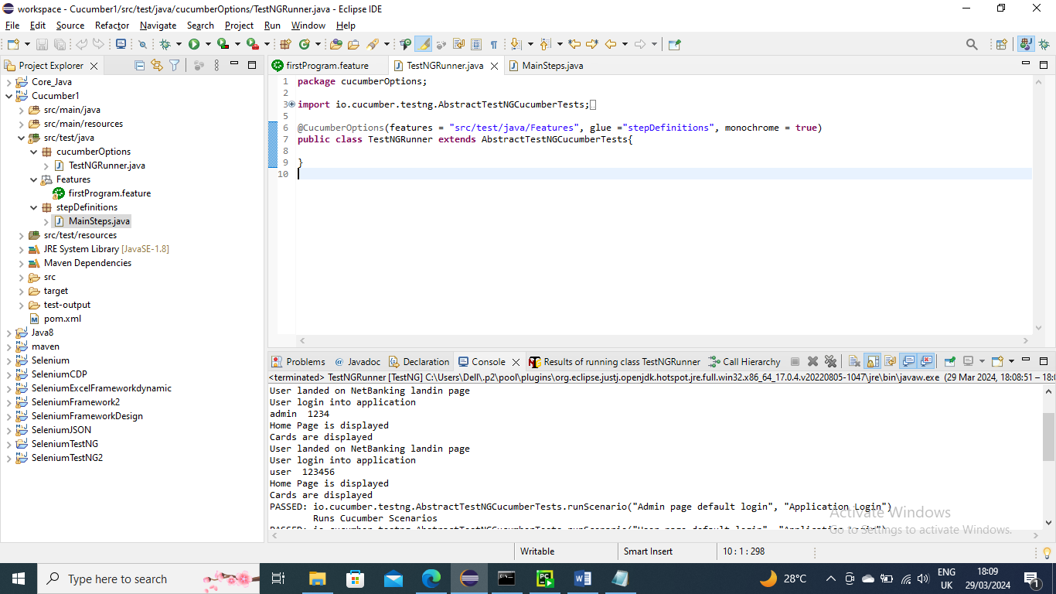

Below is the output and as you can see the paramters that are passed are handled in the methods

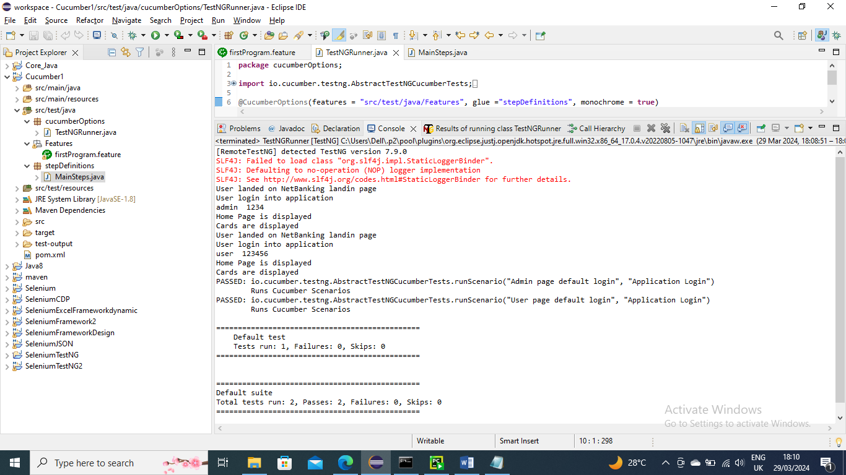

--------------------------------

Passing multiple parameters in one condition (when for example)

Let’s say you want to send multiple parameters of username and password for user page

You need to make scenario to scenario Outline and make username value to “<fieldname>” and password value to “<fieldname>”

In the examples the first row columns name should match above field name to pick it

Below is the feature file example

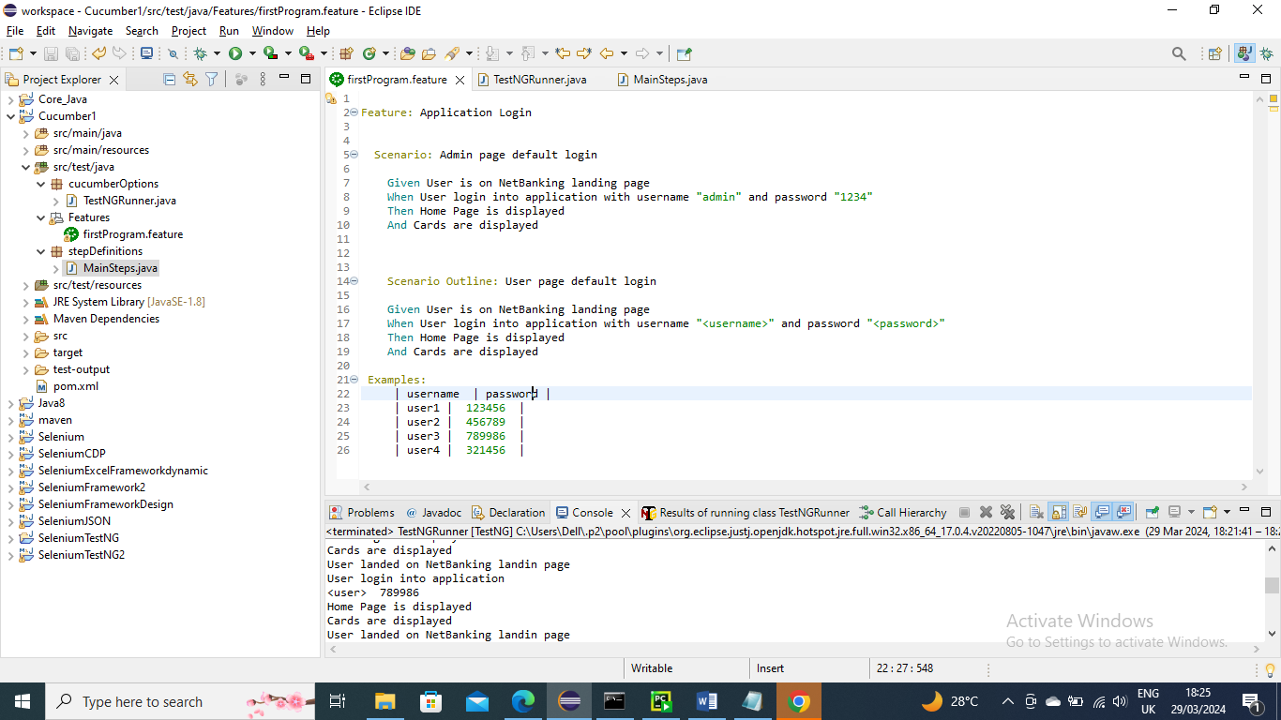

Below is the stepDefinition which handles String values

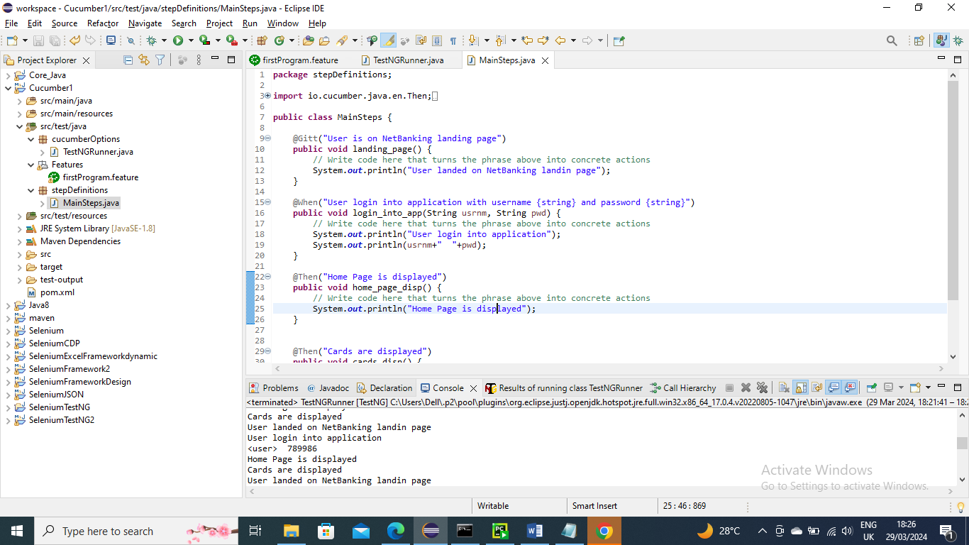

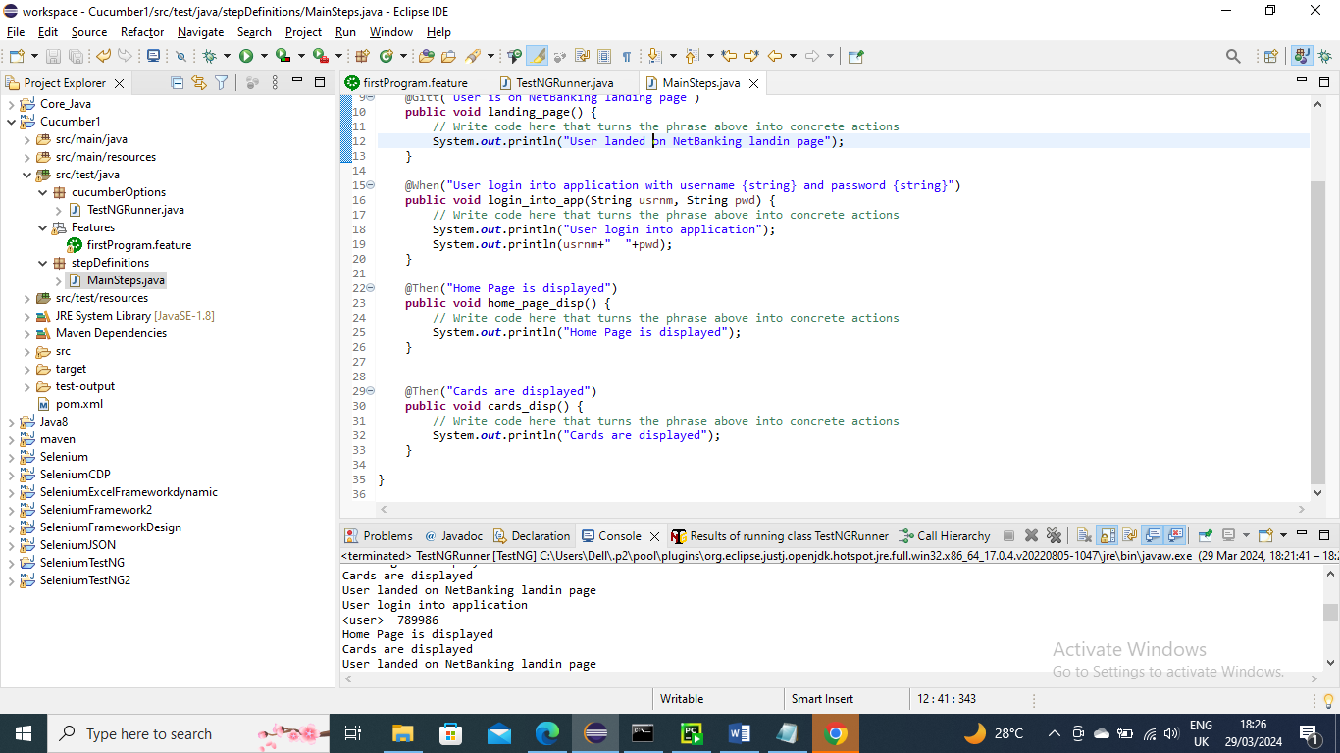

Run the main class

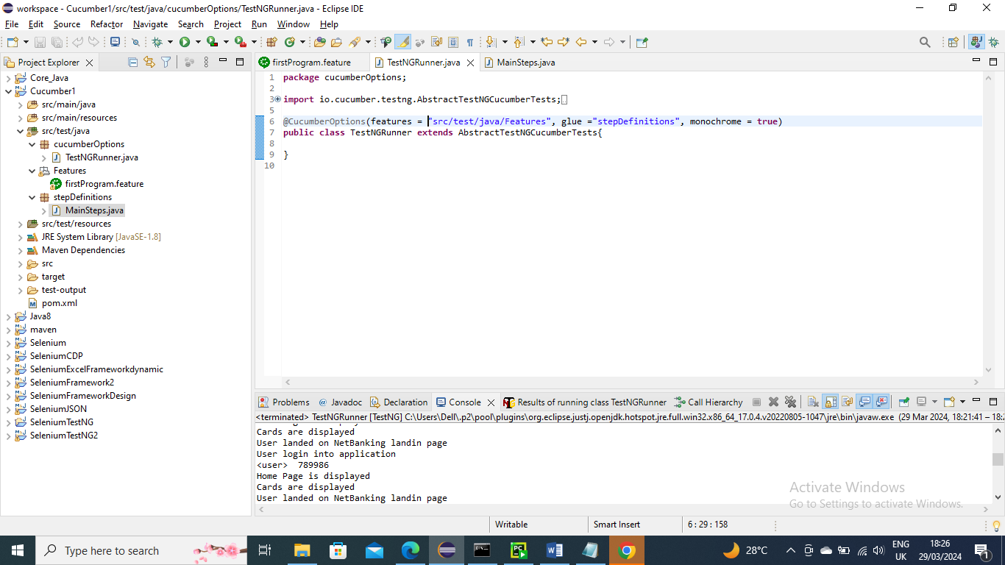

Below is the Output……as you can see multiple parameters are passed for user login method

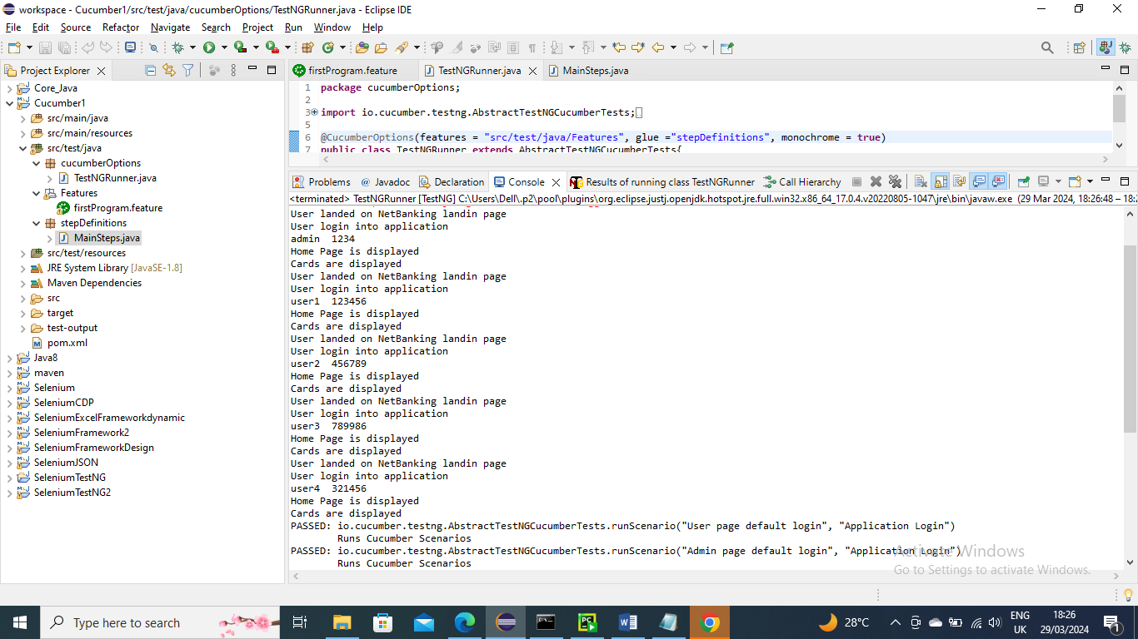

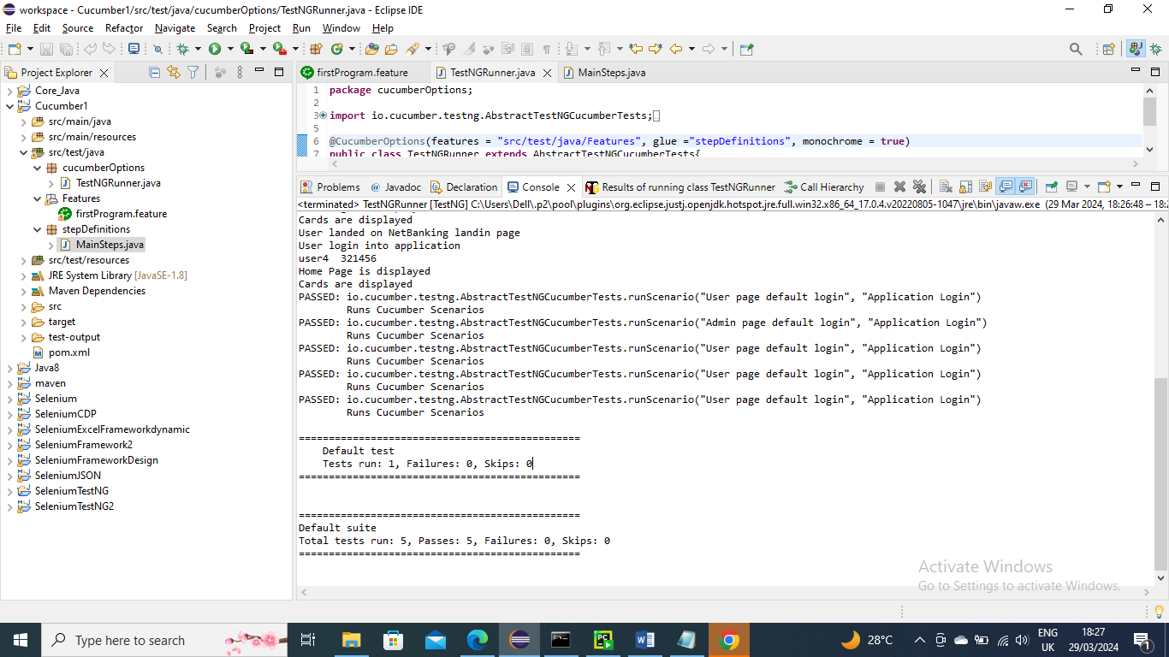

---------------------------

Below is an example where instead of parameters in String you want to send int or any other type.

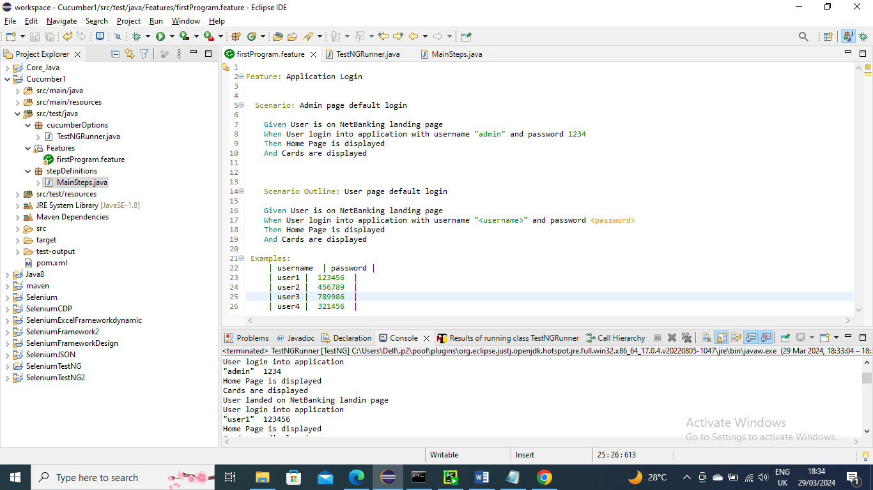

To handle this in method we need to make it regex expression “(.+)” means it will handle String or int or any…….and it should start with “^” and end with “$” symbol

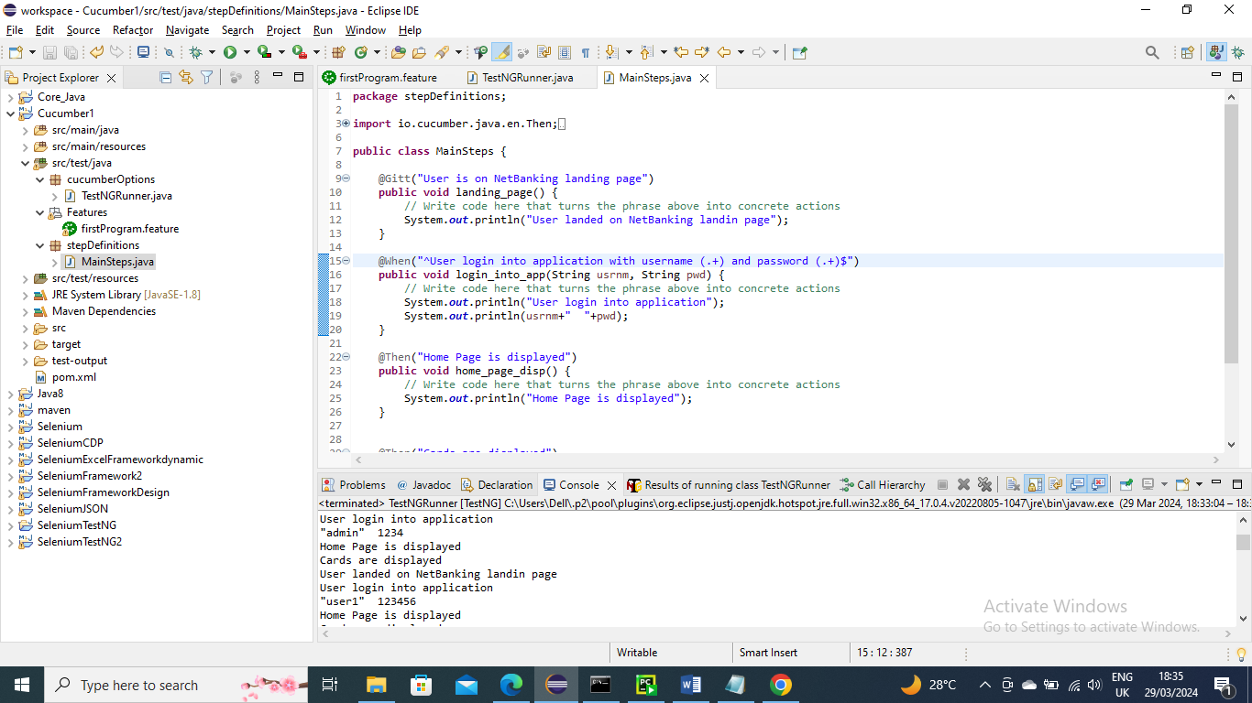

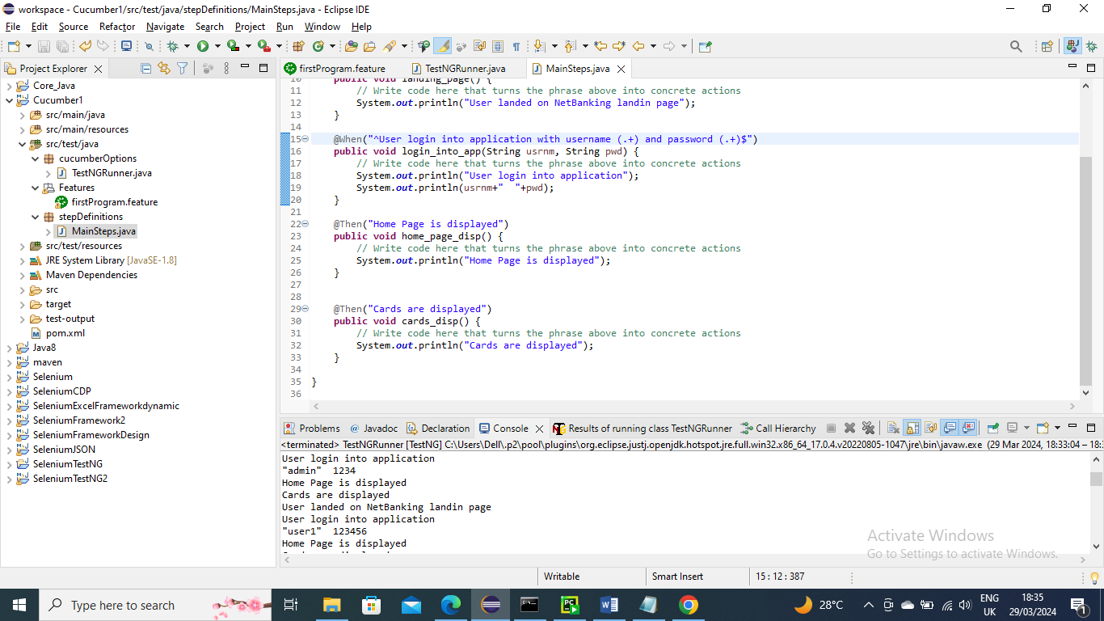

Run the main class as usual

Below is the output…..The method has handled int values as well along with String



